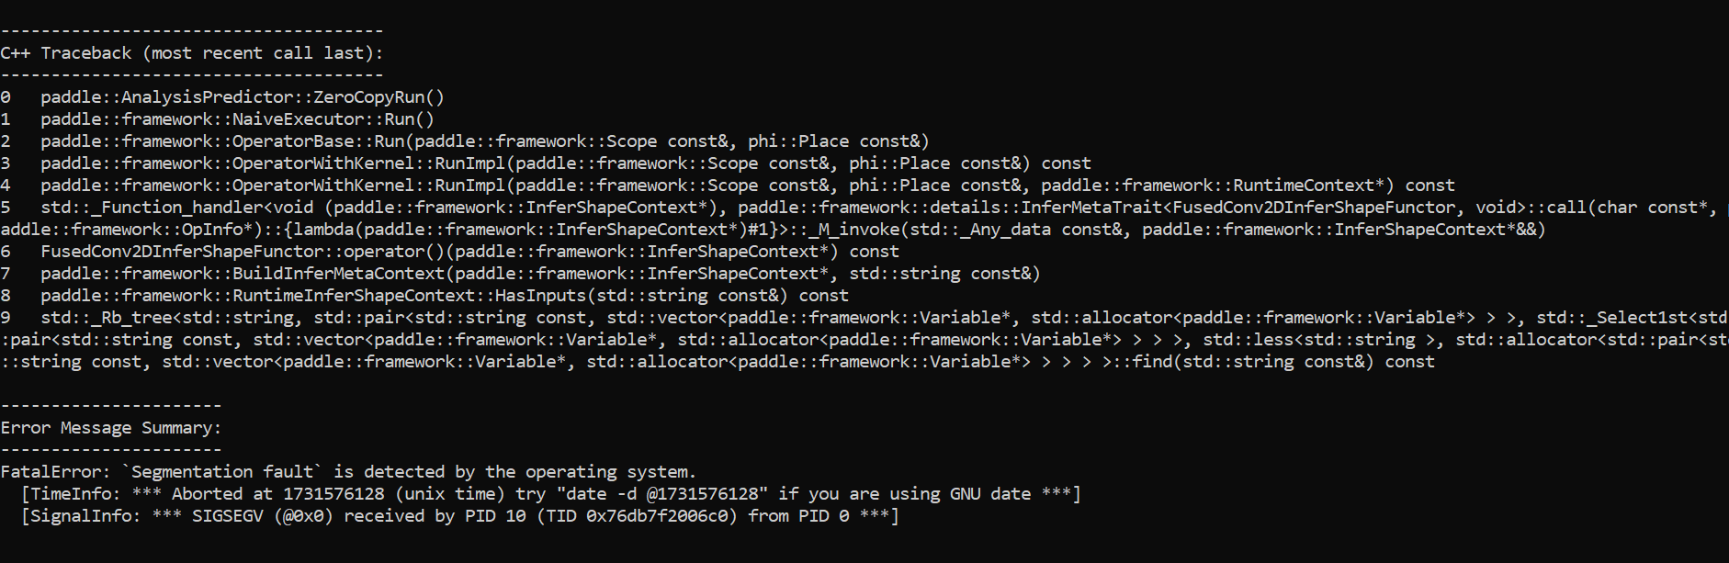

**Issue: ModuleNotFoundError: No module named 'paddle'**

The error you're encountering (ModuleNotFoundError: No module named 'paddle') indicates that the Python environment cannot locate the paddle module, which is essential for running the setup.py script in PaddleDetection.

**Solution:**

Follow these steps to resolve the issue and ensure a smooth installation of PaddleDetection:

**1. Ensure PaddlePaddle is Installed**

First, confirm that **PaddlePaddle** is installed in your Python environment:

pip show paddlepaddle

* If it's not installed, install it using the following command:

pip install paddlepaddle

* If you're using a GPU, make sure to install the GPU version of PaddlePaddle:

pip install paddlepaddle-gpu

* Verify the installation by checking the installed version:

python -c "import paddle; print(paddle.__version__)"

If you see no error and the version prints correctly, PaddlePaddle is installed properly.

**2. Activate the Correct Environment**

If you're using a virtual environment (such as venv or conda), ensure it's activated:

* For virtualenv:

source /path/to/your/virtualenv/bin/activate

* For conda:

conda activate <your-environment-name>

**3. Re-run the Installation**

After confirming that PaddlePaddle is installed and the environment is set up, go back to the PaddleDetection directory and re-run the installation:

cd /path/to/PaddleDetection

python setup.py install

**4. Check for Other Issues**

If you still face issues, it may be due to conflicting versions of libraries or outdated packages. To resolve this:

* Update PaddlePaddle and other packages:

pip install --upgrade paddlepaddle

pip install --upgrade setuptools

**5. Verify PaddlePaddle Installation**

Finally, ensure that PaddlePaddle is functioning correctly by running this command:

python -c "import paddle; print(paddle.__version__)"

If it runs without errors and prints the version, PaddlePaddle is correctly installed, and the setup script for PaddleDetection should work as expected.

Once the ModuleNotFoundError is resolved, you should be able to proceed with the installation of PaddleDetection without issues.